**Self-Neglect and Hoarding Risk Assessment and Clutter Image Rating Guidance Tool**

This document is for guidance purposes and to be used to prompt discussion with the individual and aide multi-agency professional planning and decision making. The document can be used at referral stage and also as an ongoing risk assessment tool.

|  |  |  |  |  |  |
| --- | --- | --- | --- | --- | --- |
| **Date of Home Assessment:** | | | |  | |
| **Individual Reference Number:** | | | |  | |
| **Name:** | | | |  | |
| **Date of Birth:** | | | |  | |
| **Address:** | | | |  | |
| **Contact Details:** | | | |  | |
| **Property Type:** | | | |  | |
| **Freeholder:** | Y/N | **Tenant – Name and Address of Landlord:** | |  | |
| **Consent to share information with Social Care, NHS and other partners:**  **Obtained** **Not Obtained** | | | | | |
| **Reason if consent not obtained**: | | | | | |
| **Are there any concerns about the person’s capacity to make their own decisions?**  **Yes**  **No** | | | | | |
| **Household Members:** | | | **Name** | **Relationship** | **DOB** |
|  |  |  |
|  |  |  |
|  |  |  |
| **Pets: (indicate what pets and any concerns you have)** | | |  | | |
| **What are the person’s views?** | | |  | | |
| **Has the person completed a self screening tool? if so are they happy to share a copy?** | | |  | | |
| **What works well for the person? Are there any known risks to self or others?** | | |  | | |
| **Are there any neighbours/members of the community who could be at risk?** | | |  | | |
| **Is there any known background information?** | | |  | | |

**When using the risk score consider whether the individual has the capacity to make a decision with regards to self-care and their environment and also consider whether the person has capacity to execute any changes to reduce identified risk.**

**Outcomes** (To guide level of intervention required following assessment, this is not exhaustive and will depend on the individual at the centre of the assessment)

**Level 1** – no intervention needed in this area.

**Level 2** – work with the adult (where appropriate), their family/carer(s), consider Care Act Assessment, consider a multi-agency approach where more than one agency is involved with the person

**Level 3** - work with the adult (where appropriate), their family/carer(s), consider Care Act Assessment, ensure that there is a multi-agency approach including risk assessment and management. Make referrals where required (e.g. Fire and Drug and Alcohol Services) and arrange Multi-agency meetings. If the adult is not engaging with what is offered and there is a high level of danger to the adult/or others raise a safeguarding concern via First Point of Contact.

**Level 4** - work with the adult (where appropriate), their family/carer(s), consider Care Act Assessment, ensure that there is a multi-agency approach including risk assessment and management. Make referrals where required (e.g. Fire and Drug and Alcohol Services) and arrange Multi-agency meetings. If the adult is not engaging with what is offered and there is a high level of danger to the adult/or others raise a safeguarding concern via First Point of Contact.

For further information refer to Shropshire Safeguarding Community Partnership Self-Neglect Guidance and Multi-Agency Guidance: [Working with Risk](https://www.shropshiresafeguardingcommunitypartnership.co.uk/media/owsj3x0w/multi-agency-working-with-risk-guidance.pdf).

|  |  |  |  |  |  |  |  |
| --- | --- | --- | --- | --- | --- | --- | --- |
| **Levels of risk identified (state level 1, 2, 3 or 4)**  **(**Complete the levels of risk identified, using the self-neglect assessment guidance on pages 3 - 6 of this document) | | | | | | | |
| **Eating and drinking** | 1  2  3  4 | **Washing/**  **bathing** | 1  2  3  4 | **Medical needs** | 1  2  3  4 | **Home amenities, furniture and utilities** | 1  2  3  4 |
| **Home and garden cleanliness** | 1  2  3  4 | **Home safety** | 1  2  3  4 | **Person’s own views of safety in home and environment** | 1  2  3  4 |  |  |

|  |  |  |  |  |  |  |  |
| --- | --- | --- | --- | --- | --- | --- | --- |
| **Clutter Rating (state level 1, 2, 3 or 4)** (Complete the clutter rating scale below using the images found on pages 7 - 9 of this document) | | | | | | | |
| **Kitchen** | 1  2  3  4 | **Bathroom** | 1  2  3  4 | **Living room** | 1  2  3  4 | **Dining room** | 1  2  3  4 |
| **Garden** | 1  2  3  4 | **Bedroom** | 1  2  3  4 | **Hallway** | 1  2  3  4 | **Other room**  ___________ | 1  2  3  4 |

**Self-Neglect Assessment Guidance**

|  |  |  |  |  |
| --- | --- | --- | --- | --- |
| **Physical well-being & self-care** | | | | |
| **Eating and Drinking** | | | | |
| 1 | 2 | | 3 | 4 |
| Aware of nutritional needs & provides excellent/good quality food and drink | Quality of food and/or drink inconsistent through lack of knowledge or effort | | Quality of food and/or drink is consistently poor through lack of effort; consistent support required to improve any quality  May be experiencing health related issues | Quality and frequency of food and/or drink consistently not a priority despite support leading to health issues of concern such as dehydration, malnutrition, infection, diarrhoea, vomiting and/or significant weight loss |
| **Washing/bathing** | | | | |
| 1 | 2 | | 3 | 4 |
| Clean, bathed and groomed regularly with clean, weather appropriate clothing | Irregular bathing and occasional weather inappropriate clothing | | Occasionally bathed but seldom groomed.  Clothing often dirty and/or unsuitable to weather conditions  Concerns that this maybe having an impact on health of low level concern which is responsive to treatment in the community | Seldom/never bathed or clean, concern regarding odour.  Dirty and/or poor condition of clothing (Maybe wholly unsuitable to weather conditions)  Poor health of significant concern such as skin infections, sores, abscesses. Likely to unmanageable within community setting. |
| **Medical needs** | | | | |
| 1 | 2 | | 3 | 4 |
| Medical advice sought proactively for all health matters.  Quantities of medication are within appropriate limits, in date and stored appropriately. | Seeks advice from professionals on matters of genuine and immediate concern.  Occasionally fails to keep appointments  Some concern with the quantity of medication, or its storage or expiry dates. Person amenable to resolving. | | Only seeks advice when illness becomes moderately severe.  Fails to keep some medical appointments and takes only partial medical advice  Significant concern with the quantity of medication, or its storage or expiry dates. | Only seeks help when illness becomes critical (emergencies), this can also be ignored.  Clear disregard for own welfare and/or fails to consistently take medication leading to physical ill health and frequent hospital admissions.  Significant mental ill health may also be of concern |
| **Living conditions** | | | | |
| **Home Amenities, Furniture and Utilities** | | | | |
| 1 | | 2 | 3 | 4 |
| Home is well maintained and useable.  Essential and additional  amenities/utilities - electric, gas, heating, water, useable toilet, shower/bath, cooker and fridge  All rooms can be used for intended purpose  No additional unused household appliances appear in unusual locations around the property | | All essential amenities/utilities - electric, gas, heating, water, useable toilet, shower/bath, cooker and fridge  Some repairs needed and amenable to repair or able to self -repair.  Not all rooms can be used for intended purpose, however, this is not causing any negative impact | Lack of some essential amenities/utilities or lack of access to essential amenities due to hoarding  In disrepair - unable and /or unamenable repair  Some rooms cannot be used for intended purpose and this is having a negative impact  Some household appliances are not functioning properly and there may be additional units in unusual places | Little or no essential amenities or  hoarding prevents safe use of any amenities within the home  Dangerous  Disrepair – significant risk to well-being of person and/or others  Broken household items not discarded  Rooms can not be used for intended purpose |
| **Home and garden cleanliness** | | | | |
| 1 | | 2 | 3 | 4 |
| Takes pride in appearance of home and garden which is accessible, maintained, clean and tidy  (ref clutter score pic 1) | | Cleanliness is not of concern  However, level of untidiness may be having some impact on well-being but manageable  (ref clutter score pic 2-3) | Unclean and/or cluttered home.  Garden is not accessible due to clutter or is not maintained.  Dirty (bad odour)  Light insect infestations  Animal/human waste  Food waste  These are having a moderate impact on person’s health and well-being and with support could be managed  Properties with children or adults with care and support needs may trigger a Safeguarding Concern / Referral to the Local Authority under a different risk  Pets at the property are not cared for  Resident not able to control the animals  Animal’s living area is not maintained and smells  (ref clutter score pic 4-6) | Hoarding within unclean environment of home and garden  Garden not accessible and extensively overgrown  Evidence of inside items stored outside  Dirty (bad odour)  Heavy insect infestations  Animal/human waste  Food waste  Visible rodent infestation  These are significantly impacting on person’s health and well-being – consider whether there is any impact on animals, other adults or children in the property also  (ref clutter score 7-9) |
| **Home safety** | | | | |
| 1 | | 2 | 3 | 4 |
| Essential safety features, secure doors and windows  Safe gas and electrical appliances, smoke alarms, Carbon Monoxide alarms  Home escape plan pertinent to needs of the person  Additional appliances/assistive technology pertinent to needs of the person | | All doors, stairways, roof space and windows in use and accessible  Possible fire risk -  Lacking/insufficient essential safety features, DIY that is not safe, concern over use of candles, overloaded electrical sockets  Lacking an escape plan | Limited access to windows and doors (may be missing or blocked)  Increased fire risk -  No essential safety features. Some possible hazards of escape/fire due to disrepair and/or clutter  Evidence of smoking  Flammable items stored in the home, consider newspapers, stocked piled continence aids, paraffin-based medications, irresponsible use of oxygen, concerning use of candles  No escape plan  Evidence of light structural damage including damp.  Person is unable to sleep in a bed and must sleep in an alternative place due to clutter or hygiene  (Rough sleeping while declining all offers of support to reduce significant risk)  Risk of entry by intruders – Problems keeping a dwelling secure against unauthorised entry due to disrepair, and the maintenance of defensible space | Access/exit via one route only or unable to exit unaided due to mobility  Property lacks ventilation due to the clutter  Stairs are unsafe  No essential safety features e.g. smoke alarms  Significant fire risk -  Definite hazard of escape/fire from disrepair or clutter- exposed  electric wires and sockets, unsafe electronic items, concerning use of candles  Evidence of cigarette burns to clothes or bedding  Evidence of small fires or burns  Unsafe storage or use of flammable liquids or gases  Property is not maintained  Property is at risk of notice being served by Environmental Health.  Evidence of damp and/or mould  Excess cold in winter with no functioning heating system or hot water  Person is unable to sleep in a bed and is forced to sleep in uncomfortable and/or insanitary conditions |
| **Own views of safety in home and environment** | | | | |
| 1 | | 2 | 3 | 4 |
| Fully aware of personal safety issues - trips, slips and falls | | Variable awareness and perception of personal safety issues, accepting of advice | Oblivious to personal safety issues and/or reluctant to accept advice due to lack of motivation or understanding | Unconcerned about personal safety issues  Lacks motivation or understanding to address concerns |

**Clutter Image Rating Scale**

Please select the photo that most accurately reflects the amount of clutter in the room/garden. The SSCP Self Neglect Guidance contains clutter images for each room in the home; however, the following images may be used for guidance and early assessment purposes.

**Kitchen**

**Image 1 (Ref home and garden level 1)**

# **1**

**Images 2-3 (Ref home and garden level 2)**

**2 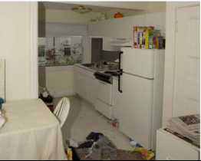 3** 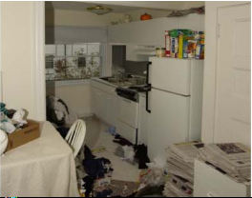

**Images 4-6 (Ref home and garden level 3)**

**4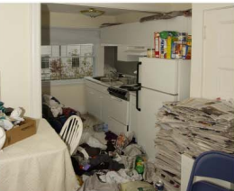 5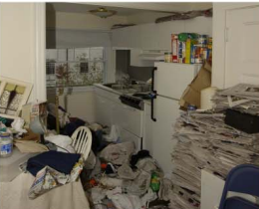 6**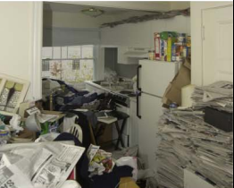

**Images 7-9 (Ref home and garden level 4)**

**7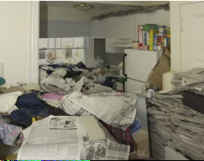 8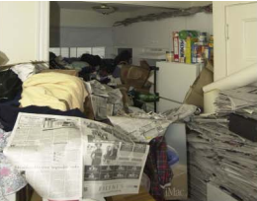 9**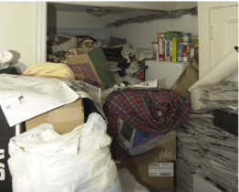

Choose an item.

**Bedroom**

**Image 1 (Ref home and garden level 1)**

**1** 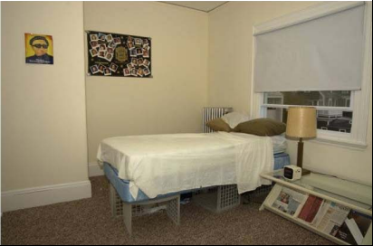

**Images 2-3 (Ref home and garden level 2)**

**2 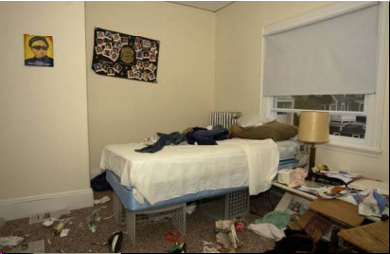 3** 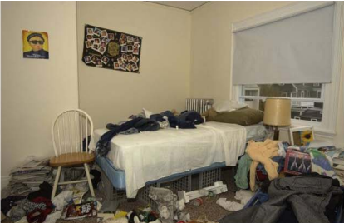

**Images 4-6 (Ref home and garden level 3)**

**4 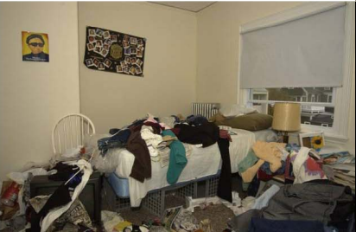 5 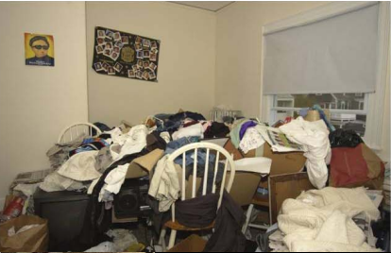 6** 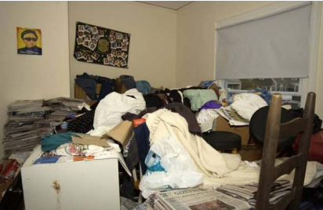

**Images 7-9 (Ref home and garden level 4)**

**7 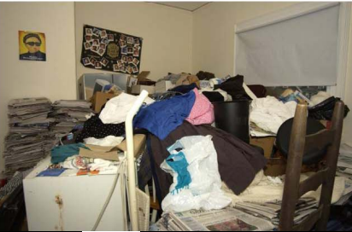 8 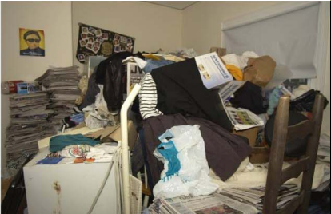 9** 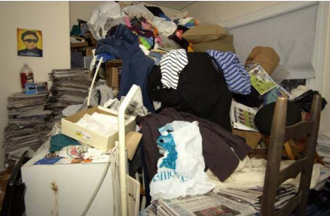

Choose an item.

**Living Room**

**Image 1 (Ref home and garden level 1)**

**1** 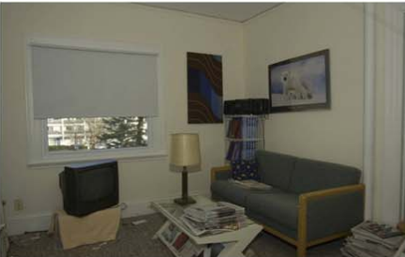

**Images 2-3 (Ref home and garden level 2)**

**2 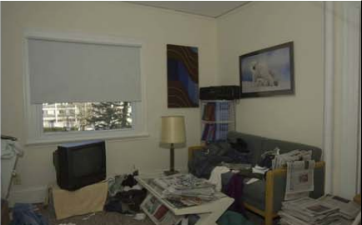 3** 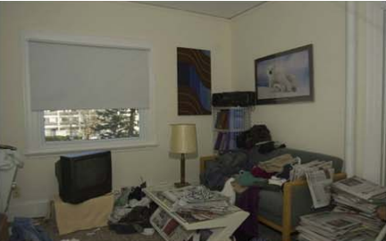

**Images 4-6 (Ref home and garden level 3)**

**4 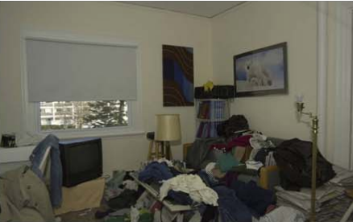 5 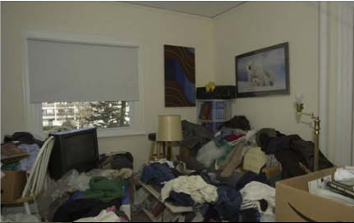 6** 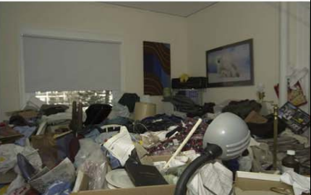

**Images 7-9 (Ref home and garden level 4)**

**7 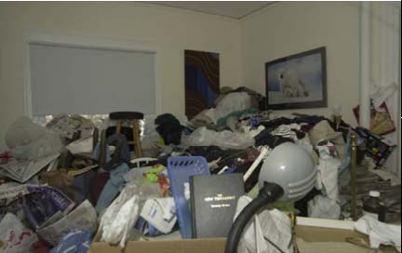 8 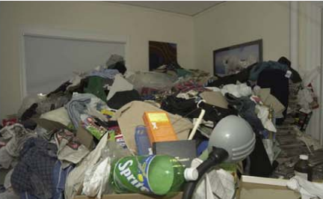 9** 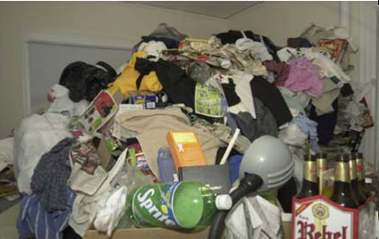

Choose an item.

*Resources used to in the production of this risk tool include: Suffolk County Council Multi-Agency self-neglect and hoarding risk assessment guidance tool, T&W Safeguarding Partnership Hoarding and Clutter Image Rating Assessment and Salford Clutter Image Rating Tool.*

The following scale above is not exhaustive but allows the professionals to consider the observed living conditions of the individual.

The score is for assessment purposes only and may be re-visited at any time to measure progress and prompt discussion with the individual and other professionals.